**Sales Analysis  
Wireframe document**

To perform deeper analysis, the sales data is divided into 6 report sections.

**Sales Quantity Analysis:**

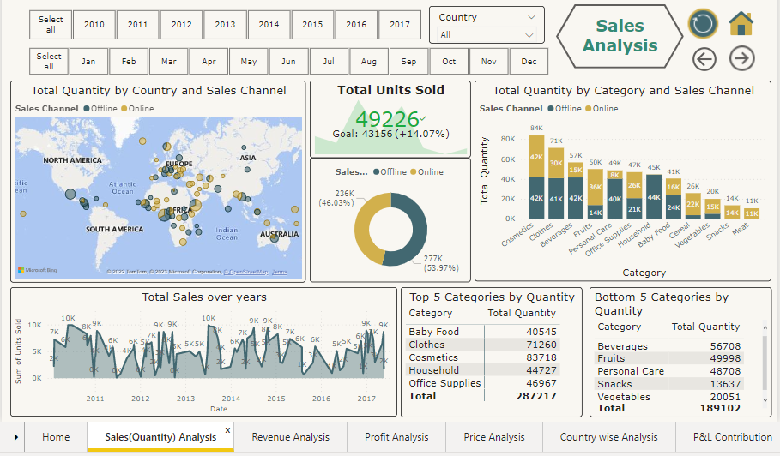

1. Yearly & Monthly Slicer is provided to get sales information of specific time frame.
2. Country filter is also provided to get sales information of specific/selected country.
3. A Map visual used to showcase country wise orders size. Sales channels are colour coded for easy identification.
4. A KPI chart visual used to showcase total Quantity sold according to the selected filters and its growth compared to Last year.
5. A Donut chart used to showcase Performance of Sales channel.
6. A column chart used to showcase Category wise Sales along with sales channel.
7. An area map showcasing the quantity sales growth over time.
8. 2 Matrix tables to showcase Top & Bottom 5 categories in terms of Quantity sales.

**Revenue Analysis:**

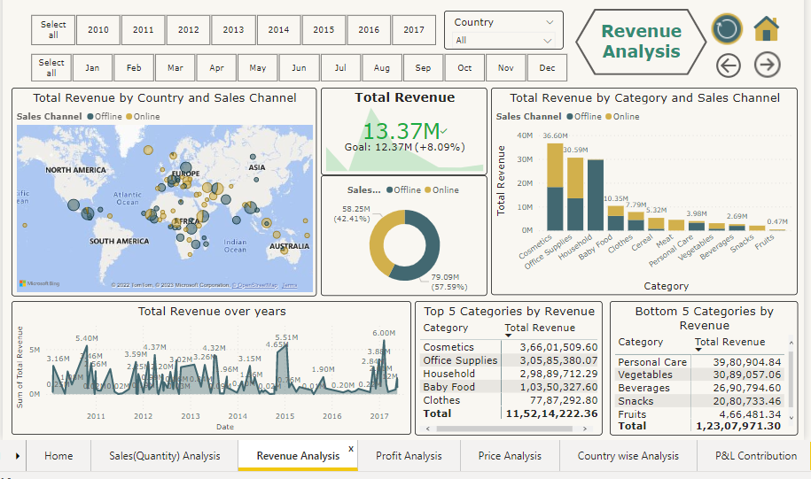

1. Yearly & Monthly Slicer is provided to get revenue generated for a specific time frame.
2. Country filter is also provided to get revenue generated from specific/selected country.
3. A Map visual used to showcase country wise Revenue size. Sales channels are colour coded for easy identification.
4. A KPI chart visual used to showcase total revenue generated according to the selected filters and its growth compared to Last year.
5. A Donut chart used to showcase distribution of revenue generated from each Sales channel.
6. A column chart used to showcase Category wise revenue along with sales channel.
7. An area map showcasing the revenue growth over time.
8. 2 Matrix tables to showcase Top & Bottom 5 categories in terms of Revenue generated.

**Profit Analysis:**

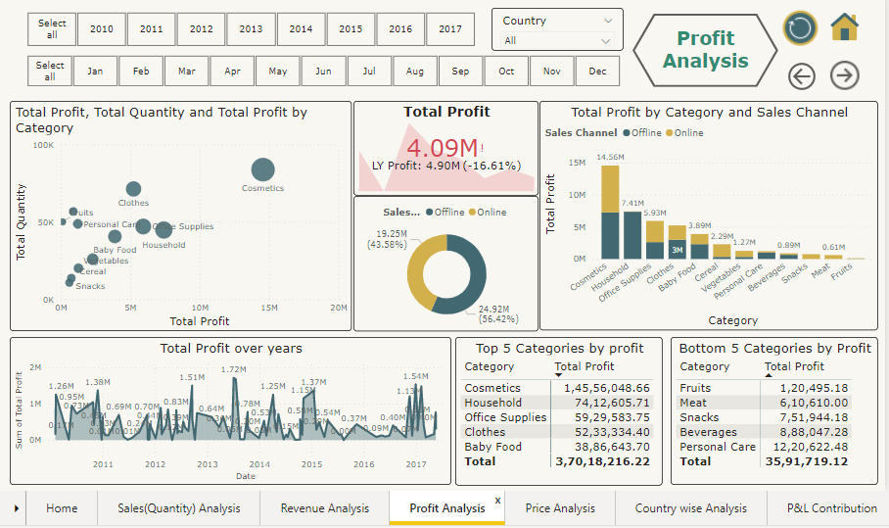

1. Yearly & Monthly Slicer is provided to get profit generated for a specific time frame.
2. Country filter is also provided to get profit generated from specific/selected country.
3. A Scatter plot visual used to showcase most profitable category along with quantity sales.
4. A KPI Chart visual used to showcase total profit generated according to the selected filters and its growth compared to Last year.
5. A Donut chart used to showcase distribution of profit generated from each Sales channel.
6. A column chart used to showcase Category wise profit along with sales channel.
7. An area map showcasing the profit growth over time.
8. 2 Matrix tables to showcase Top & Bottom 5 categories in terms of profit generated.

**Price Analysis:**

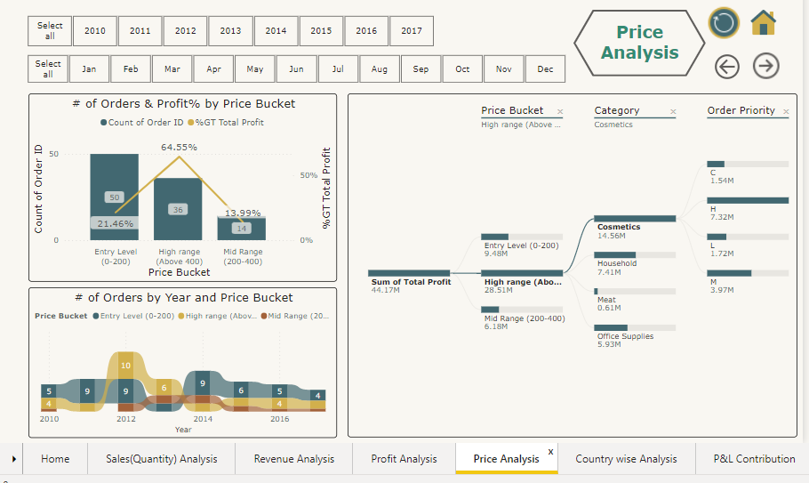

1. Yearly & Monthly Slicer is provided to get profit generated for a specific time frame.
2. A Line & Stacked column chart is used to showcase different Price ranges and profits earned from the categories falling in the price range.
3. A Decomposition chart used to analyse profit explained by price bucket, category & order priority.
4. A ribbon chart visual used to showcase the ranking of price ranges over period of time to understand customer preference.

**Country wise Analysis:**

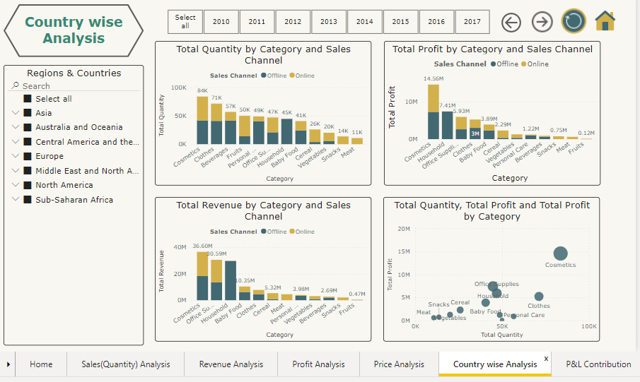

1. Yearly Slicer is provided to get profit generated for a specific time frame.
2. Regions filter along with countries is provided to filter region/country specific data.
3. Stacked column charts used to showcase sales Quantity, Total Profit & Total Revenue by Category and Sales channel.
4. A Scatter plot visual is used to showcase Category performance in terms of Quantity as well as Profits.

**P&L Contribution Analysis:**

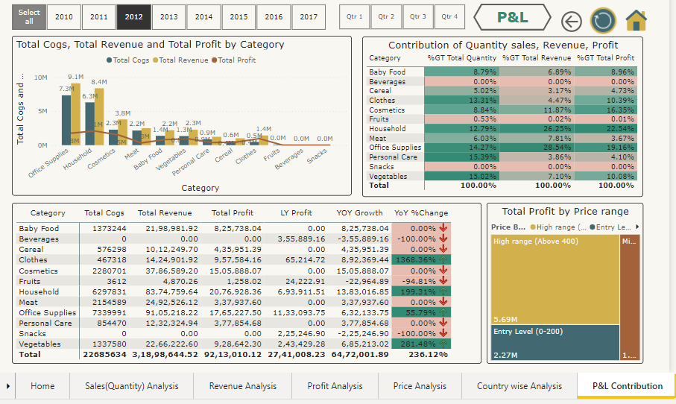

1. Yearly & Quarterly Slicer is provided to get P&L data of specific time frame.
2. A Column chart is used to showcase Total Cost price, Total Revenue and Profit trend by Categories.
3. A Matrix table is used as a Performance analyser which highlights the hero products in terms of Sales quantity, Revenue & Profit.
4. A matrix table is used to check the YOY profit growth & % change in YOY profit growth to identify positive/negative growth compared to last year.
5. A Tree map is used to showcase Profits from each Price bucket.